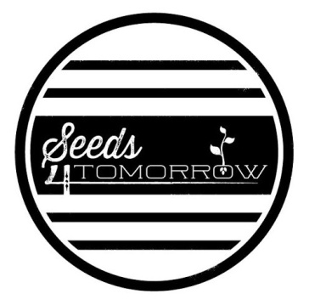
SEEDS4TOMORROW ADVENTURE CAMP APPLICATION FORM

Please return application form to:
Hawaii Agriculture Research Center
Seeds4Tomorrow Adventure Camp
P.O. Box 100
Kunia, HI 96759
Applicant’s Name:

Seeds4Tomorrow Adventure Camp Checklist:
1. Complete paper application with parent signature
2. Submit payment* with application or online at: http://www.harc-hspa.com/registration-and-contact.html
*$50 Camp Tuition may be paid through Paypal, by clicking on “Donate” button or by check, made payable to Seeds4Tomorrow, HARC or Hawaii Agriculture Research Center
APPLICANT INFORMATION
Applicant’s Full Legal Name:

Preferred Name/Nickname:

Email Address:

Phone Number:

Home Address:

Gender: Male Female

Date of Birth: Age:

Country of Citizenship, if other than US:

Current School: Grade:

PARENT/LEGAL GUARDIAN INFORMATION
Parent’s Information

Last Name: First Name:

Address:

Email:

Place of Employment:

Occupation:

Work Phone Number:

OTHER
- Is there any information concerning academic performance that you would like to share with us that would benefit us? ☐ Yes ☐ No If yes, please explain:

- Is there any information concerning medical history (including allergies and medications) that you would like to share with us that would benefit us?

Allergies: ☐ Yes ☐ No If yes, please explain

QUESTIONS FOR THE APPLICANT TO ANSWER:
How did you learn about the Seeds4Tomorrow Adventure Camp?

What are your reasons for applying for the Seeds4Tomorrow Adventure Camp?

CERTIFICATION
By signing this application form, you are agreeing to the following statements:
I affirm that the information contained in this application and all supporting documentation is true and accurate to the best of our knowledge.
I affirm that we have fully disclosed all pertinent information concerning the applicant. I understand Hawaii Agriculture Research Center (HARC) reserves the right to withdraw acceptance if any significant information has been withheld during the admission process that would affect the admission decision.

I am/We are the parent(s)/guardian(s) of the student named above. By signing below, I/We:
- Give permission for the student(s) to participate in the excursions and activities during the dates of the one week Adventure Camp;
- Give permission for the student(s) to travel by the transportation provided by the Seeds4Tomorrow Adventure Camp;
- Release HARC and its agents and employees from any and all liability to us and to the student(s) for any injury, damage, or loss that occurs because of the student’s participation in the excursion and activity, unless the injury, damage, or loss is caused by the negligence or willful misconduct of the agents and employees;
- In the event of illness or injury to the student(s), consent to and authorize such medical and dental treatment as may deemed necessary, and agree to pay for such medical and dental costs;
- Grant to HARC and its representatives and employees the right to take photographs/video of me and my property in connection with the Seeds4Tomorrow Adventure Camp. I authorize HARC, its assignees and transferees to copyright, use and publish the same in print and/or electronically; and.
- I agree that HARC may use such photographs/video of me with or without my name and for any lawful purpose, including for example such purposes as publicity, illustration, advertising and web content.

- I have read, understand and agree with the above.

Parent Signature (required): Date:

